FINAL PROJECT:

The Constellation Dress

Maedeh Sharifi

Elio Bidinost and Sabine Rosenberg  
CART 360 Tangible Media and Physical Computing

December 7th, 2017

**Research Documentation**

Initial sketch

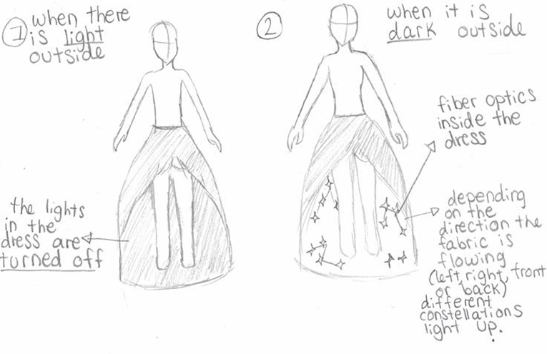

Map of constellations

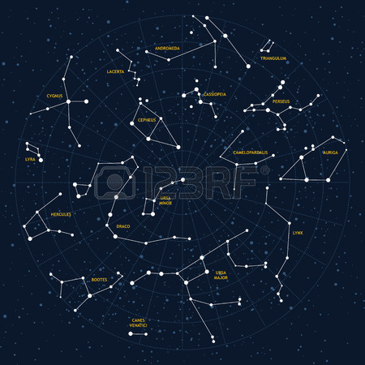

Source: <http://www.go-astronomy.com/constellations.htm>

Sketch on the position on each constellation in the dress

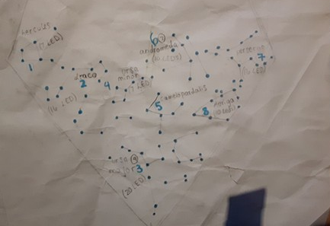

Name of all the constellations:   
1. Hercules  
2. Draco  
3. Ursa Minor  
4. Ursa Major  
5. Camelopardalis  
6. Andromeda  
7. Perserus  
8. Auriga  
  
Tutorial on how to make a hoop skirt for my dress :

<https://www.makeit-loveit.com/how-to-make-a-hoop-skirt-a-sturdy-non-wobbly-version/>  
  
Tutorial on how to use the magnetometer:  
<https://www.sparkfun.com/tutorials/301>

**Circuit Schematic**

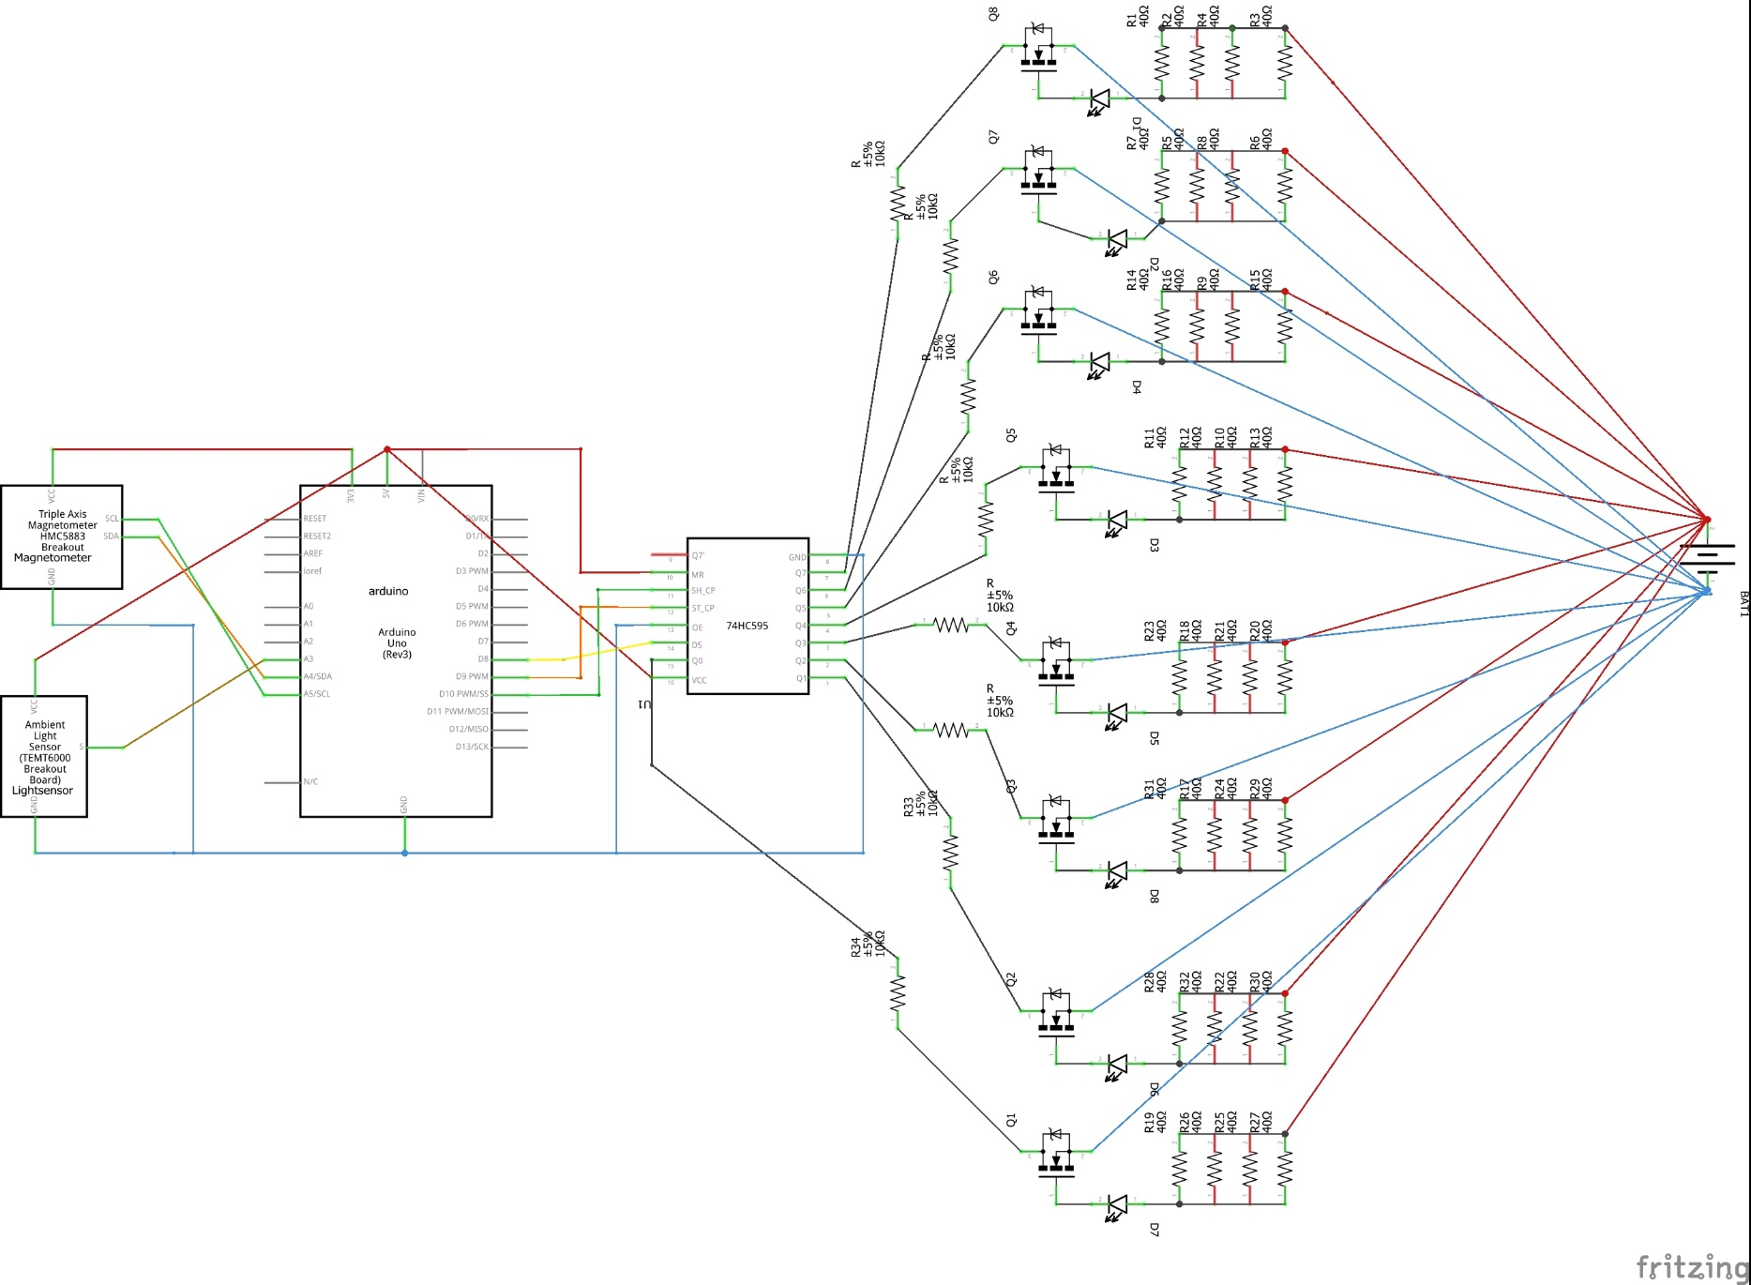

**Creation process**

Circuit of the dress is glued to a belt

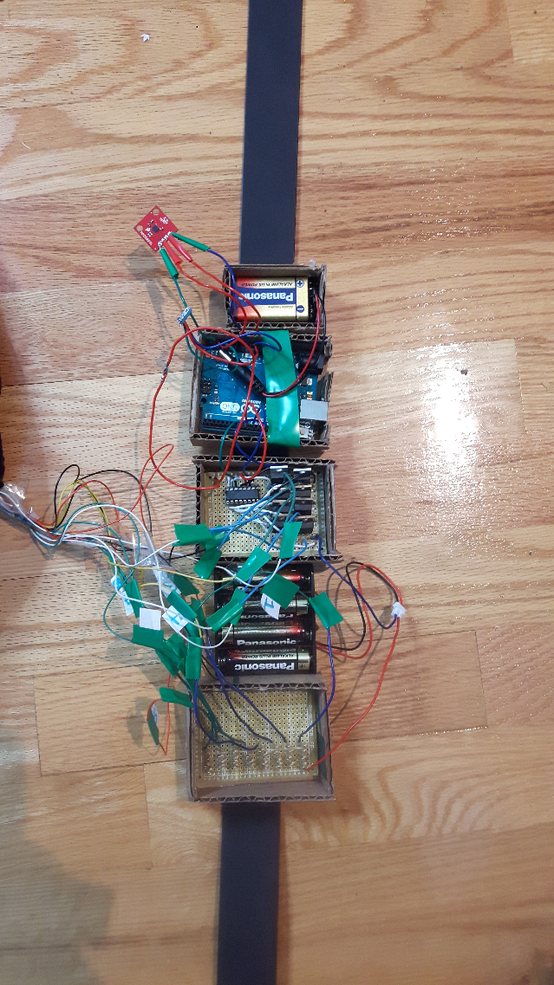

Textured fabric on the back of the dress / Fabric inside the dress + LEDs

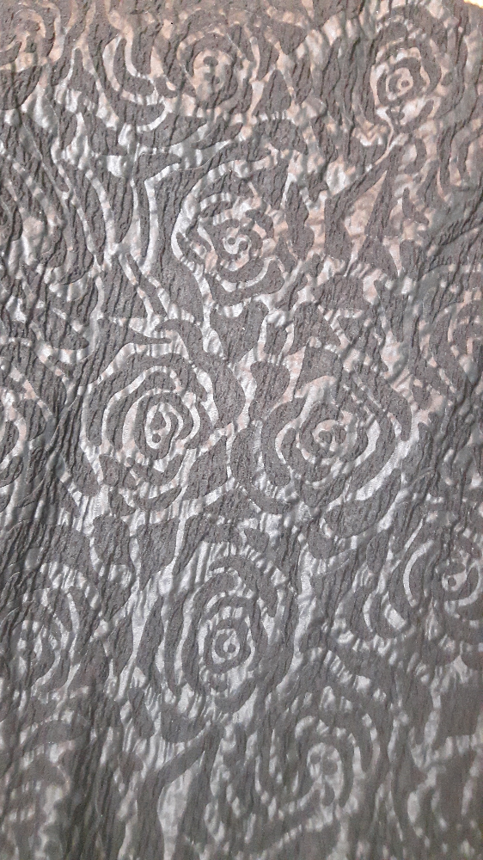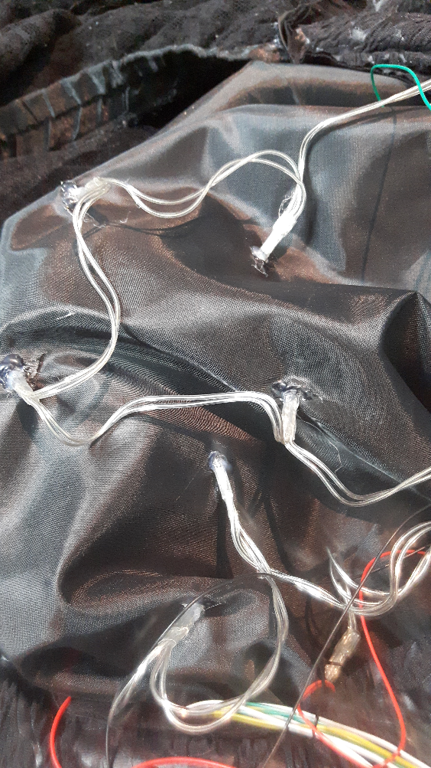

Fabric in the front + LEDs Fabric + sparkly tile

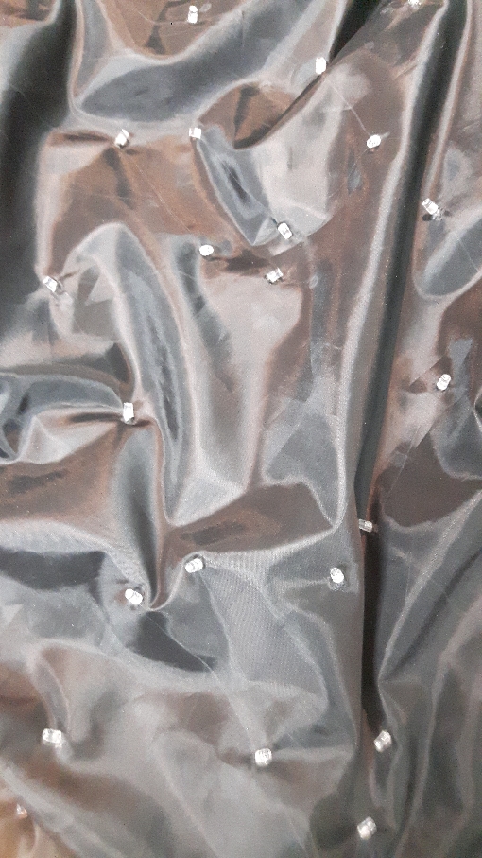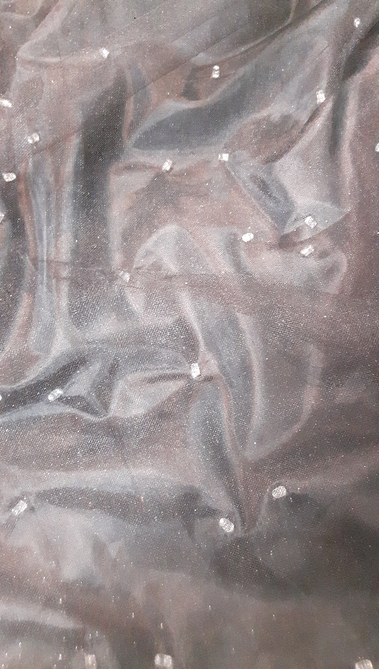

Back of the dress Front of the dress

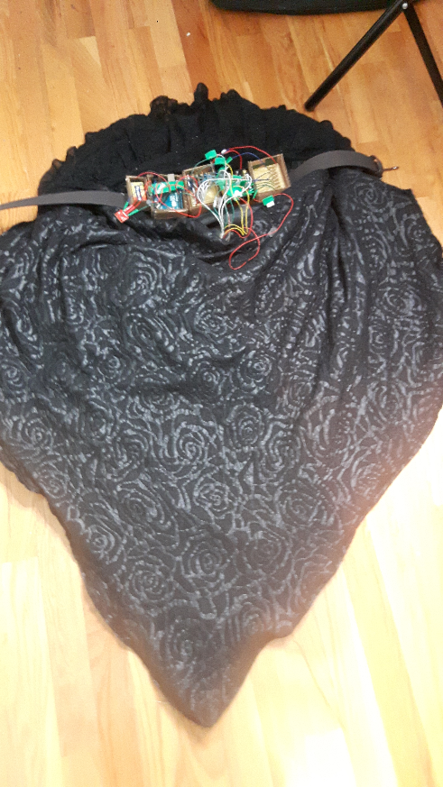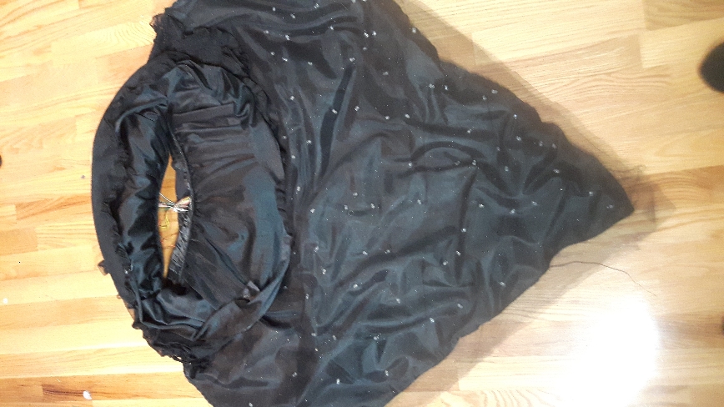

**Final Result**  
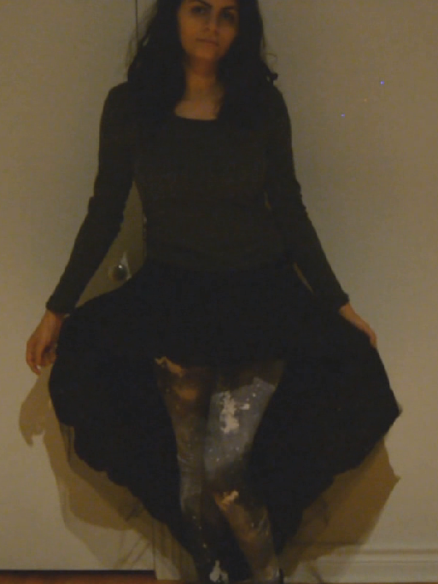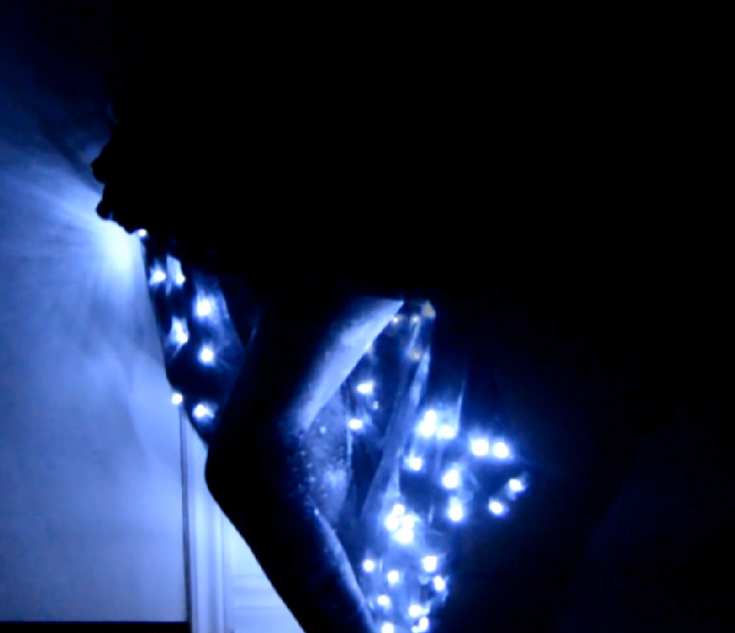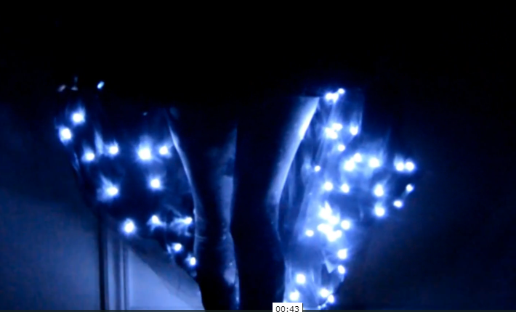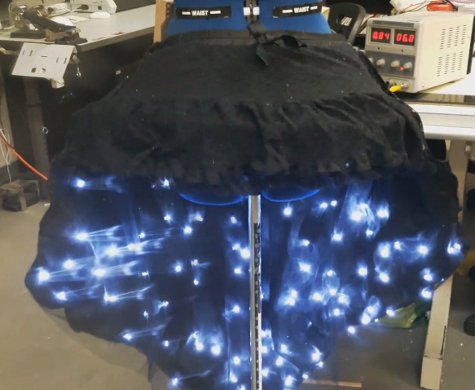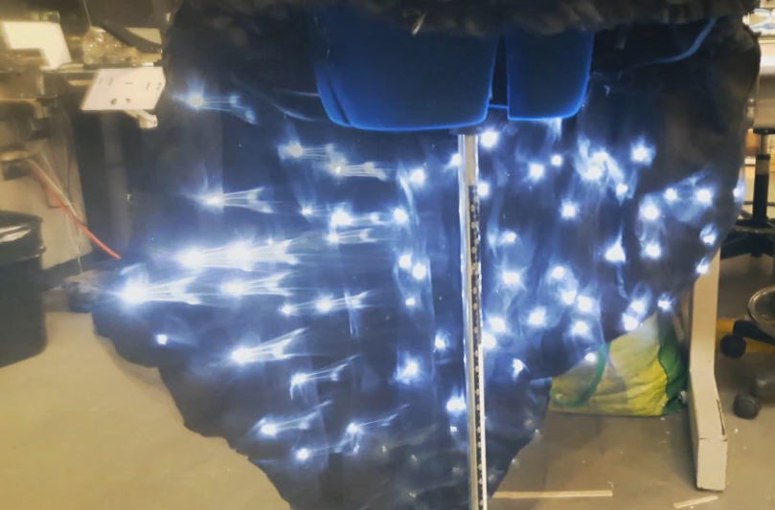

**Video of the dress:** https://vimeo.com/246373679